
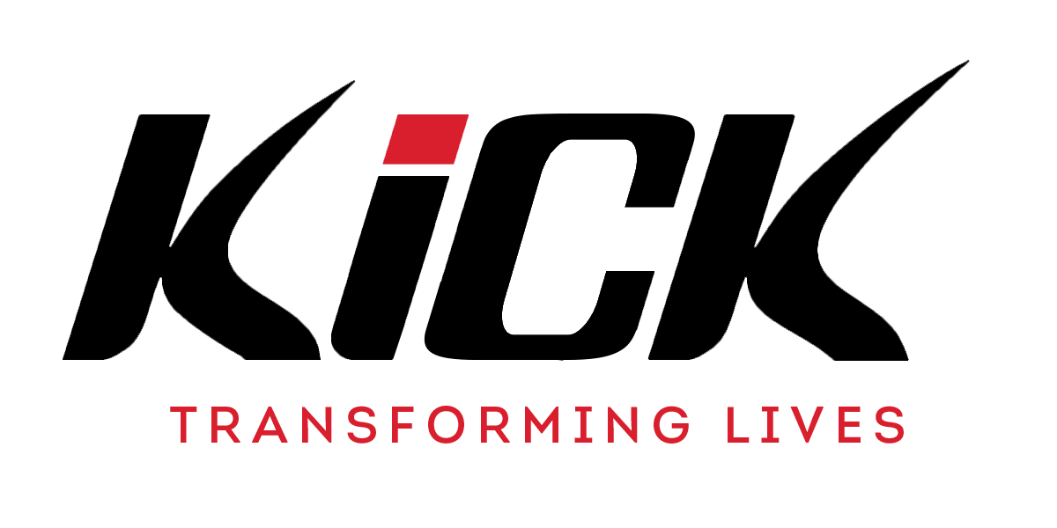
Director of Finance Application Pack

KICK’S MISSION
At KICK, we are motivated to respond to a sense of hopelessness in many young people today as 1/3 of young people aged 15 identify with a mental health condition, 2million grow up without a father at home, many are disconnected from local communities with 95% now not attending church. We aspire to see a generation of young people who will reach their God given potential; where communities have been socially impacted; and where spiritual change has transformed a nation. Our mission is to transform young people’s lives, with God's love, through sport and support. We do this through values-driven physical education, street dance, mentoring, chaplaincy in schools and community KICK Academies to impact a sense of hopelessness and give them a hope for the future and a joy in the present.

KICK work in Infant, Junior, Primary, Secondary, Pupil Referral Units, Private and Special Schools to deliver the following services with Christian values embedded throughout every session:
- PE National Curriculum - Transformational Street Dance
- Solutions Focused Mentoring - Schools based Chaplaincy

In all that we do we seek to live out our values to encourage young people to be aspirational, to be compassionate in all circumstances, to deliver excellent quality sessions, and to be intentional in building relationships and sharing the Gospel with young people every day and to show integrity in our decision-making at all times. We are a growing charity, currently working with over 100 schools and have established 30 KICK Academies across the UK. Our staff team has more than doubled over the last 3 years, with KICK now employing over 90 staff. As an organisation, we are engaging with over 30,000 young people every week and are coming closer to achieving our vision to reach a generation of young people within a generation of time.

KICK APPLICATION PROCESS
Please send your CV and covering letter to our Director of HR – beccilee@kick.org.uk
Your covering letter should include the following areas and should clearly show how your skills and experience meet the requirements for this post.

Aspirational - We believe in being aspirational towards our young people and in all that we do.
Please share your aspirations within the role of Finance Director and how to intend to drive the role to be a success.

Compassionate – We believe in showing compassion to every young person we engage with.
Please tell us about your experiences as a Christian and how you have shown compassion within interactions with colleagues and key partners previously.

Excellence – We believe in striving for excellence in every area of our work and learning. Please tell us about your previous experience where you have shown excellence in your approach and execution of projects, as well as how your skills and experience are relevant to this post.

Intentional Relationships – We believe in taking opportunities and making intentional relationships with both young people and partners of KICK. How are you suited to serving and developing the work of KICK through your management and leadership?
Integrity – We strive to be a people of integrity in our actions and all our decision-making. What makes you stand out from others to make us bring you in for an interview?
If you do have any questions, please connect beccilee@kick.org.uk

KICK JOB DESCRIPTION

Title: Director of Finance
Based in: London/Outside negotiable
Hours of work: Part Time (3 days)
Line Manager: Chief Executive Officer/Chief Operations Officer
Salary: £43,900 - £45,250 (pro rata to 3 days ACTUAL £26,340 - £27,150)

Role Purpose:

The purpose of this role is to help deliver KICK’s vision by providing direction to ensure strategic and operational financial oversight. This will include day-to-day tasks such as, financial planning, budgeting, reporting and financial analysis. The successful candidate will provide both strategic and financial guidance to ensure that KICK’s financial commitments are met excellently and accurately. The role will also involve working closely with both the Senior Leadership Team as well as the board of Trustees to provide strategic recommendations and maintain and grow a solid foundation for KICK to grow.

Key Responsibilities and Accountabilities:

Financial Strategy
- Ability to advise the CEO and board on financial strategy to achieve business objectives.
- Provide financial guidance for company activities, including investments, mergers, and acquisitions.
- Contribute to commercial negotiations with customers and suppliers.
- Embody our ACEII values and work together with other KICK leaders and managers to enhance quality practice and standards across KICK.

Financial Management
- Oversee and optimise financial management to maximise returns to ensure tight controls of finances, resources and contracts to meet budget, targets and outcomes.
- Create and manage KICK's budget, forecasting, and planning processes to optimise our finances.
- Responsible for accurate and timely monthly finance reporting to the Senior Leadership Team and Board on KICK performance.
- Responsible for processing and running payroll, along with sessional payments and expenses.
- Ensures stability, establish discipline, sets financial benchmarks and manage financial risks.
- Responsible for billing and chasing invoices.
- Complete KICK's Annual accounts, engaging auditors and meeting Charity Commission compliance.
- Responsible for the management of our Bookkeeper to ensure targets are met, as well as providing line management support and guidance.

Impact Measurement and Systems
- Embody our ACEII values and work together with other KICK Managers to enhance quality practice and standards across KICK.
- Responsible for a data dashboard, Impact Measurement and updating management information at KICK.
- Identifying and maximising effective IT hardware, software and systems to ensure efficient processes to enhance KICK operations and prepare us for growth.

Person Specification:
Proven Experience
- A qualified accountant.
- Proven experience in a senior management role.
- Experience of strategic planning and business development.
- Experience of complex and multi-dimensional problem solving whilst having a clear knowledge of the options, impacts, risks when suggesting a resolution.
- Experience of communicating with senior executive leadership in matters of strategic importance. The applicant should have the ability to influence internal and external partners to understand and accept concepts, practices and approaches of the job area.
- Experience of collating monthly accounts and annual accounts as well as managing various budgets across an organisation.

Skills and Abilities
- A good understanding of IT packages and systems.
- A forward thinker with the ability to be proactive in improving current activities and processes.
- Ability to empower, motivate and lead others through supporting teams to succeed, investing in the capabilities of staff and providing clear feedback.
- Ability to show responsibility and accountability for quality outcomes whilst keeping a firm focus on priority management.

Personal Qualities
- The Desire to own, guards and deepen KICK’s Christian ethos, vision, mission and values.
- Able to take the initiative and be a self-starter.
- Passionate to see young people and staff progress and achieve their full potential.
- Clear Enhanced DBS.

Professional Competencies
 | MASTERY PATHWAY: DIRECTOR
 | Directs as Head of a Function for the organisation. Establishes and implements tactical and operational plans for the function, with significant impact on the achievement of Functional Results. Focus is on strategies (3 years or less) to achieve organisational results, which may require substantial development of new processes, standards or operational plans to achieve strategies.
A | Seeing the big picture | Owns, guards and deepens KICK’s Christian ethos. Prays through decision and discerns way forward in organisational matters. Scans the political and wider context to maximise the impact of implementation strategies. Facilitates continuous improvement; transforms services and supports Strategic Aims. | Eg 1-5
A | Achieving entrepreneurial outcomes | Identifies new opportunities, considering market forces and customer needs. Promotes innovative business models, new commercial partnerships and secures agreements to deliver added value to KICK’s mission.
C | Changing and improving | Nurtures and drives growth. Provides a sense of safety. Forward thinking and proactive. Responsible for improving entire processes or systems, leveraging on personal experiences and best practices to improve the competitive position of the organisation. Continuously seeks ways to improve process implementation and build a leaner, more flexible and responsive organisation.
C | Building capacity for all | Empowers others to self-organise. Fosters a sense of connection and belonging. Responsible for developing mid to long-term plans to optimise their responsibilities with talent required to succeed. Coaches and invests in the capabilities of staff, to be effective now and in the future - giving clear, honest feedback and supporting teams to succeed as a conscious unconscious competence. Effective in ability to delegate and matrix manage Directorate
E | Making effective decisions | Problems are frequently complex and multi-dimensional, requiring broad-based consideration of variables that impact multiple areas. Directs evidence-based strategies, evaluates options, impacts, risks and solutions to understand the root cause. Predictive ahead of being reactive to future problems.
E | Delivering at pace | Leads from the front showcasing timely performance with energy and taking responsibility and accountability for quality outcomes. Keeps a firm focus on priorities, addresses performance issues resolutely, fairly & promptly. Typically has substantial latitude for hiring, firing and promotion within guidelines.
E | Managing a quality service | Creates an environment to deliver the desired operational service standards. Shapes senior managers to lead others and projects. Open to new ideas and fosters organisational learning. Requires advanced business knowledge, general management, and leadership capability to lead functional teams. Typically has broader practical experience across multiple professional disciplines, combining theory & past practical experience for KICK’s practices.
I | Leading and communicating (Internal) | Is visible, establishes a strong direction and persuasive future vision; manages and engages with people in a lovingly truthful way. Able to communicate with senior executive leadership in matters of strategic importance. May be required to negotiate and compromise to influence internal and external partners to accept concepts, practices and approaches of the job area.
I | Collaborating and partnering (External) | Communicates with partners within and outside of own job function, internally and externally. Rapidly responsive in personal communications. Adept at leveraging possibilities for the organisation from external interactions. Approachable to partners, delivering organisational objectives by creating an environment that is available to challenge however uncomfortable.
I | Delivering value for money | Accountable for Directorate performance ensuring tight controls of finances, resources and contracts to meet budget, targets and outcomes. Builds a performance culture where staff are given space, authority and support.
I | Skills | Typically, a Degree or equivalent experience, QTS and minimum 15 year’s experience of leadership and management.

