St Lawrence’s Hungerford: Children and Youth Minister

About our church
Our vision is to become more Christ-like for the sake of God’s world, through worship, discipleship and outreach.
We are a Church of England parish church in the small town of Hungerford, West Berkshire. We are a friendly, welcoming church with about 160 members and strong links to the wider community of Hungerford. As the only Church of England church in the town, our worship ranges from the traditional to contemporary. We have a variety of groups and activities such as Alpha courses, Bible study groups, Sunday School, weekday baby and toddler groups, Holiday Club and more. Our members are diverse and come from a range of different church backgrounds.
Whilst our church family includes children and young people, we are conscious that they are under-represented compared to the wider community we serve. Creating the post of Children and Youth Minister (CYM) is part of our vision to share the good news of Jesus with all our community and become a church where everyone feels at home as the family of God, covering all ages. We call it ‘Growing our Living Church’. We’re looking for someone who’ll share that vision (together with our broader vision of becoming a more Christ-like church that is compassionate, contemplative and courageous), and work with us to make it happen.

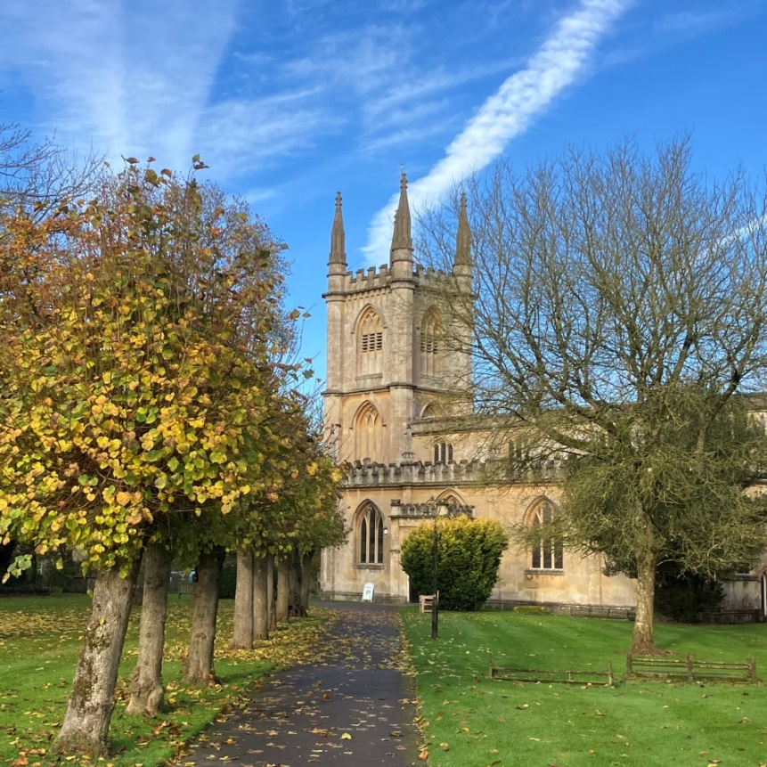

Our church is characterised by
- Welcome – everyone is welcome, and we really mean it. That includes the large number of visitors to the area (about 50 people visit the church each day), people from the canal or those living nearby.
- Courage - we recently completed an £810k redevelopment of the back of our church “Building for the Future” to provide excellent new facilities. This was a step of faith, financially, and shows the commitment of our congregation to the future. Having built the building, we are similarly committed to building disciples - children and young people, the family of God. This is part of our ‘Growing our Living Church’ initiative.
- Every member ministry – a large proportion of our members, from the newest (eg those who’ve come through Alpha) to the oldest (in their mid 90’s), serve and are involved in small teams. We actively encourage members to volunteer and serve, and we also draw in those on the fringe of the church too.
- Growth - a commitment to develop people and help them grow through discipleship pathways. We have active home groups, training courses and more.
- Mission – a ministry that encourages all church members to take part in outreach, and especially to eat with their neighbours. Our recently re-launched St Lawrence’s lunches aim to draw in community to eat with us too.
- Environment and community – our monthly working parties, volunteering to paint canal locks, plant trees or tend the marsh, both improves the local environment and draws in volunteers from outside church too.

Find out more about our church
- Our website: http://www.stlawrenceshungerford.org.uk/
- Email: Rev Mike Saunders vicar@stlawrenceshungerford.org.uk
- Call: 01488 208341
- Or come & visit us.

Our Missional Strategy
We have recently developed a Missional Strategy to be more intentional about our activities. Within our vision we have 4 priorities which are
Worship = to love God
Discipleship = to become more Christlike
Mission = to love our neighbours in word and deed
And Engaging Every Generation

We are working hard to increase our engagement with every generation in Hungerford. Our Missional Strategy therefore includes a section about children and youth work.
Looking at the structure and membership currently, our programmes and activities for adults are more developed, and the programmes for our children and youth are less developed. This is because we have 160 adult members and something like 32 children and youth, many of whom are occasional attenders. Adult church members are equipped and released to lead their own programmes, whereas children and youth need adult leaders and helpers.
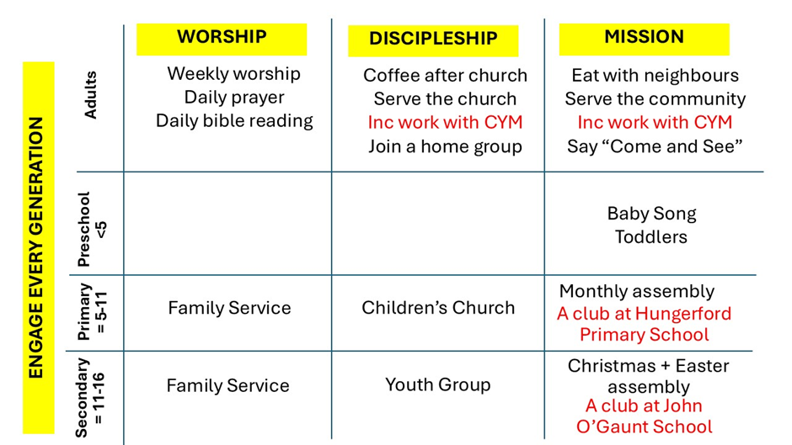
When our CYM is in post and established, we are hoping and praying they will have added further activities (in red) to our existing programmes (in black). Perhaps something like this:

We are aware that our new CYM may bring specific skills and have defined areas of interest, and we would be very keen to ensure that the CYM was able to play to those strengths within their work with our children and youth. We are a place that values ministry in this area.

About the Children and Youth Minister role

Job description
We have a modest number of children and young people in our congregation, who we want to support and enable to grow in faith, and we also want to reach out to younger people in the wider community. We are seeking a Children’s and Youth Minister (CYM) to build on the work of our previous workers and volunteer team members, and lead our work in this area.
The focus will be on primary and secondary school ages, with occasional involvement with other age groups.
There will be three main areas of work:
- Developing the links between home, school and church including strengthening the partnership with our primary and secondary schools:
  - Working in the local primary and secondary schools, subject to agreement with the head teachers. This could include running clubs, contributing to lessons, assemblies or providing support to students.
  - Outreach to the wider community. We envisage a range of events which are attractive to children, teenagers and families with a range of different levels of engagement with the church and Christian commitment. Possible activities might include sports, music, drama, outdoor activities, providing a social context to meet.
Presenting the Christian faith in an appropriate, engaging way will be an important element, alongside providing opportunities for young people to socialise, learn and interact with others. Working in partnership with others in the community, such as the Youth and Community Centre is encouraged.
- Enabling the discipleship of children and young people in our community.
- Enabling and skilling the church membership to serve our young people in Hungerford by building up and encouraging the team of existing and new volunteers.
We are looking for a CYM who can work with us within our vision, but can also identify needs and opportunities and take the initiative.

Scope for Growth for our Children & Youth Activities
The role will partly be what you make it, but the aim is that it enhances our current activities and builds new ones, so that in time, it could look like this, with new activities in italics:
Weekly
- Children’s Church – Sunday mornings, term time
- Youth Group – Sunday early evening, term time
- Holiday Church – activities for any children who are in church on Sunday mornings in school holidays
- Club for primary school age - at school, church or elsewhere using sports, drama, outdoor activities or something else
- Club for secondary school age - at school, church or elsewhere using sports, drama, outdoor activities or something else
Termly
- Assembly at primary school
- Assembly at secondary school
Monthly
- Involvement with the existing All Age Services
Annual
- Summer holiday club
- Boosting activities for children at church-run events like the fete, open gardens
- Boosting our outward-focused services which appeal to children and youth, such as Christingle, Easter Egg hunts
- Youth weekend, or leading a youth group to suitable Christian event
- Working with students to ease the Year 6 to Year 7 school transition
Other
- Practically supporting our parents, eg suggesting training or resources
- Engagement with students returning for holidays; encouraging our young people to play a part in the Quiet Revival
- Re-skilling the congregation and encouraging engagement through volunteering directly or supporting work in other ways

Scope for growth for our Children & Youth Minster
We want to support our CYM and invest in personal and professional development; to make space for growth as an individual and leader, and a space to retreat. We are a place that values our ministers, and encourages people to fulfil their potential.
There is scope to develop the role to build on the skills and interests of the successful candidate, within the context of a work programme agreed with the line manager. The CYM will be expected to be flexible and from time to time take on other duties as the line manager may reasonably require. They will need to work in different locations, mostly within Hungerford.
As we value each staff member’s ministry, training is part of our ethos, and we want to support our CYM in their personal and professional development. Space will be given for adequate preparation for ministry and events. Space will also be given for time to retreat.
Training opportunities will depend on the person appointed, and could include:
- Youthscape Essentials
- Childrens’ Ministries Essentials
- Other Diocesan training courses, such as ‘Spacemakers’, Intergenerational Worship, the Diocesan online training hub etc
- Diocesan partnerships with other organisations / initiatives such as The 30k Project, St Mellitus, CMS Pioneer Mission, Cuddesdon
The line manager will be the Vicar, who will meet regularly with the CYM, both 1:1 and with other leaders/staff. Our Curate ran Holiday Club in 2024 and 2025, but leaves us shortly for her next role. We have a strong volunteer team and an embedded volunteering culture. We also have part time administrative support. The CYM will attend the weekly staff meeting, and PCC at least termly.
The church will provide an agreed budget for resources, to run events and for training.

Children and Youth Minister: Person Specification

Essential Requirements
- Understanding and support for the Church’s vision and values.
- Track record of delivering youth and children’s work, preferably including working with a church or Christian organisation.
- Ability to communicate the Christian faith to young people and children in an effective and appropriate way and to communicate well with their parents/carers.
- Understanding of young people and children, including the context in which they are growing up.
- Ability to work effectively as part of the church community and in teams alongside volunteers and paid staff.
- Experience of coordinating and leading adult volunteers, preferably in a youth and children’s work context.
- Good understanding of safeguarding issues.
- Commitment to ongoing training.
- An enhanced DBS Disclosure will be required for the successful applicant.
- Occupational Requirement for the post-holder to be a Christian in accordance with the Equality Act 2010.
- Eligible to work in the UK.

Desirable Requirements
- Experience of working in schools.
- Knowledge of the local area in and around Hungerford.
- To be a full member of the church, worshipping with us most Sundays. If the role is taken as a job share, we may consider appointing someone who is a member of another Church and wishes to remain so, it will however be necessary to be available regularly on Sundays.
- Training in youth and/or children’s ministry, or a willingness to train.

Children and Youth Minister: Terms, Conditions & Applications

Outline of terms and conditions
Rate of pay: Up to £32,000 per annum, based on experience, to be paid monthly in arrears. (A lower salary level will apply for those at an early stage in their career to allow for training.)
Hours: Full time: 37.5 hours per week. Hours to be agreed but will include working on weekends and some evenings. Although a full time role is preferred, a job share may be considered.
Holidays: in addition to Bank Holidays, the post will carry an entitlement to 24 days paid holiday per year, together with an additional 3 days between Christmas and New Year. There may be occasions on which the CYM works on a Bank Holiday, in which case time may be taken in lieu. Holidays should be agreed in advance with the line manager, and there will be limitations on how many Sundays may be taken.
Pension scheme: the church will pay a 5% contribution in addition to a 3% contribution by the staff member.
Contract: 3 years in the first instance with the potential for renewal. The first 6 months will be a probationary period.
Accommodation: Accommodation is not supplied, but there is scope to explore whether a room may be available within the church family, especially for those may be moving to the area.

Applications
Applications should take the form of a Curriculum Vitae and Covering Letter. The Covering Letter should explain how you meet the Essential and Desirable requirements of the job and should not be longer than 2 pages of A4 size. Please include a short paragraph explaining how you came to faith, and the name of the church where you currently worship. Please also supply the names and contact details for two people who can act as referees, noting whether or not we may contact them in advance.
Please email applications to vicar@stlawrenceshungerford.org.uk. We do not have a formal closing date but will proceed with interviews as soon as we have suitable candidates.
If you would like further information or to discuss the post, please email or call Rev Mike Saunders on vicar@stlawrenceshungerford.org.uk or 01488 208341.

