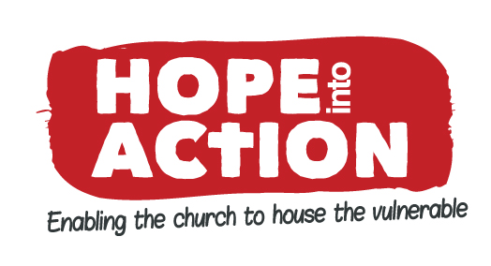

HOPE INTO ACTION Milton Keynes - Equalities Monitoring Form
By completing this form you will help us to evaluate the accessibility and appropriateness of our recruitment, and events and services to people with protected characteristics. Funders require us to collect this information and it helps us to meet our obligations under the Equality Act 2010. Please tick as many boxes as suits your identity. Thank you.

Ethnic Background
Asian | Black |  |  | White |  | Other
  Bangladeshi
  British
  Indian
  Pakistani
  Other
  African
  British
  Caribbean
  Other
  British
  Irish
  European
  Other
  Chinese
  Latin American
  Middle Eastern
  Other
  Prefer not to say
Gender and gender identity |  |  |  |  | Sexuality |  | Marriage and Civil Partnership
 |  |  | Is your gender identity the same as you were assigned at birth? |  |  |  | Are you:
  Female
  Male
  Trans (female to male)
  Trans (male to female)
  Other
  Prefer not to say
  Yes
  No
  Prefer not to say
  Bisexual
  Lesbian
  Gay
  Heterosexual
  Prefer not to say
  Married
  Civilly Partnered
  Single
  Prefer not to say
 |  |  |  |  |  |  | Pregnancy and maternity
Are you:
Pregnant
Recent Mother
Prefer not to say

Disability or health issue
Our work is informed by the social model of disability - that it is social 'barriers' which cause 'disability', rather than impairments. The Equality Act 2010 defines a disability as: “a physical or mental impairment which has substantial and long-term (lasting more than 12 months) adverse effect on your day to day living”. Do you consider yourself to have a disability?

 | Yes |  | No |  | Prefer not to say

 | Blind / Visually impaired |  | Deaf / hearing impaired
 | Learning difficulty |  | Mobility
 | Mental Health |  | Other disability
 | Other health issue |  | Prefer not to say

Religion |  |  |  |  | Age
  Agnostic
  Atheist
  Buddhist
  Christian
  Hindu
  Humanist
  Jewish
  Muslim
  Sikh
  None
  Other
  Prefer not to say
   | 16-18 |  | 51-60
   | 19-21 |  | 61-70
   | 22-25 |  | 71 plus
   | 26-30 |  | Prefer not to say
   | 31-40
   | 41-50

