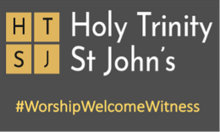

CYPF Resource Hub Lead – Families & Children 0-8 yrs

Background

Holy Trinity with St John’s, in partnership with the Diocese of Rochester’s Called Together Programme and funded by the National Church’s DIP programme, seeks a Resource Hub Lead for Families and Children aged 0-8 years.

Four and a half years ago, two existing churches, Holy Trinity SE20 and St John the Evangelist Penge, merged to become one church. Both legacy churches have a long history and a deep sense of calling to work with children, young people and families, and the merger has brought new energy and life into this work. This has been recognised by the Diocese in our identification as a Resource Hub.

We seek a Resource Hub Lead to work with our existing team of committed, capable, creative and enthusiastic volunteers to strengthen and develop this work among families with children aged 0-8, in line with the Project Aims and our church’s Mission Priority to grow as an intergenerational community of faith. As part of the wider Called Together programme, the role also involves working with linked parishes to support and develop work with this age group.

Called Together and Holy Trinity with St John’s Vision

The Vision for Rochester Diocese is this: “Seeking first the Kingdom of God, we are called together to change, grow and serve with compassion, courage and creativity.”

We recognise that seeking God’s kingdom means joining in God’s work to build a Church where all can flourish and enjoy life in all its fullness as God intends. Our church’s vision comes from John 10 verse 10:

Jesus said, “I have come that they may have life, and have it to the full”.

We are people of all ages from different backgrounds and experiences being drawn together as a community of faith, united by the deep and life-giving love and compassion shown to us through God's son, Jesus Christ.

Having received God’s gift of life, we seek to share that life by offering kindness, care and loving service to those who come to our church, to our local community of Penge, and to the wider world.

As a church, we long for people to find a spiritual home where each person is loved and valued for who they are, and where we can grow together and flourish in the varied gifts which Jesus has given us.

We are a people of faith, learning together, guided by the Holy Spirit, to discover more of the fullness of life and power of Jesus, and to join in God’s work in the world.

At Holy Trinity with St John’s, we:
- worship the God who created us, saved us, and offers us life in all its fullness.
- welcome all with the love that we have received from Jesus.
- witness to our experience of the Holy Spirit’s work in our lives, in words and acts of loving service.

Our Priorities

We seek to live out our vision to be a community of worship, welcome and witness through three core mission priorities:
- to grow (in depth of relationships as well as in number) as an outward-looking, intergenerational community of faith.
- to empower and enable all to flourish, use, and develop their gifting in a variety of ministries and leadership.
- to build on the tradition of both legacy churches in serving the local community; to grow as a church for our community which reflects that community.

Existing Strengths upon which you will be able to build

As our Resource Hub Lead, you will not be starting from nothing. Holy Trinity with St John’s has flourishing activities for and excellent relationships with families with young children both on Sunday mornings and throughout the week. You will be working with strong teams of enthusiastic and committed volunteers – with over twenty adults involved in Sunday morning children’s and youth work during an average month, a team of eight to ten at our toddler group, Little Fish, and a wider group of more than forty people who are willing to give support at special events such as Messy Church.

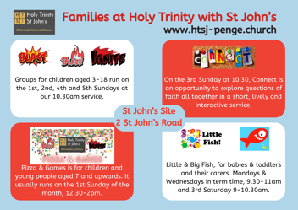
We regularly welcome around 30 children and young people, from babies to Year 13, at our Sunday morning services. Separate groups for 3-7 year olds, 7–11-year-olds and young people at secondary school run every Sunday except the 3rd in the month. Once a month, after the service, we host children and young people from aged 7 and upwards for Pizza and Games, a relaxed space with time to enjoy being together. We have just launched a new break-out space, Sparkle, within the worship area for children under 3 and their parent/carer.

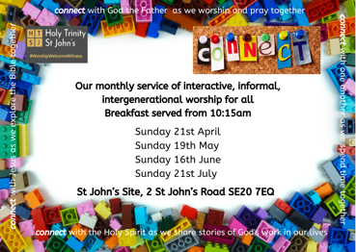
Our Intergenerational service, Connect, on the 3rd Sunday specifically aims to engage and draw families with children into the heart of our worship as church. This is an hour-long, café-style, informal service with an emphasis on learning together through talking and doing. In recent months, we have celebrated our diversity in Christ via fruit salad, built a service around the baptism of five children, and hosted an Instant Nativity.

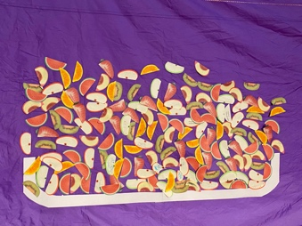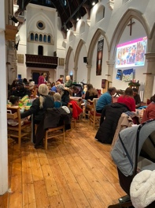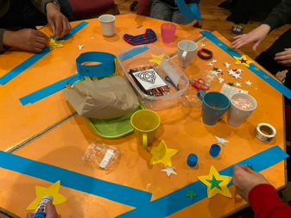


Our toddler groups, Little Fish (Mondays and Wednesdays during term time) and Little Fish Saturdays (once a month), regularly welcome up to 60 families to a session for free play, a Bible story, refreshments, and song time. A team of researchers from Christchurch Canterbury recently spent several weeks with us as part of their research into spirituality in young children and declared this group to be “gold standard”.

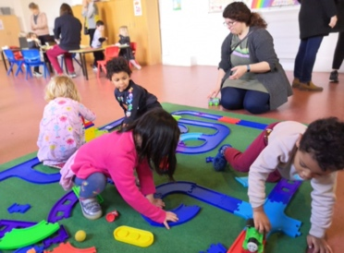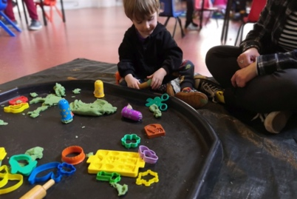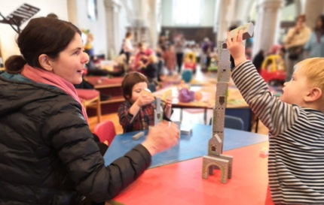

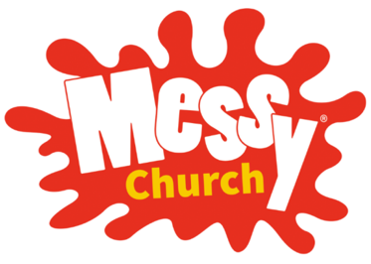
Messy Church, which we run seasonally, regularly attracts over 100 people, most of them not regular church families. At our Messy Easter service on Good Friday, we welcomed 140 people, including 74 children, for painting, planting, play dough, icing biscuits and reflections on the cross and the empty tomb. This happens thanks to our team of over 20 volunteers.

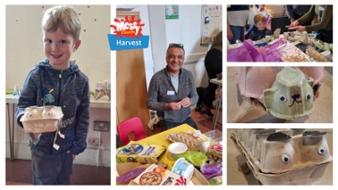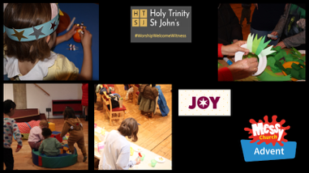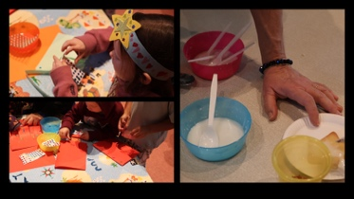

We have strong and positive relationships with our local primary schools, especially but not exclusively, our church school. St John’s Primary invite us in for a weekly assembly and come to us for their end of term services, and each class visits at least once during the year for RE. We take seasonal assemblies at other primary schools in the parish, and welcome children for visits especially around Christmas and Easter.

Areas of Potential Growth

- Empowering the team, with spiritual nurturing and by building on existing strengths so that helpers have confidence to lead and others are encouraged to join in this work
- Building on the work being done in schools and engaging with families “at the school gate” and in the school context – helping to sustain relationships with our toddler families into primary school
- Working with the CYP and wider Worship & Preaching and other teams to make our worship and welcome as inclusive as possible for neurodivergent children and those with additional needs
- Supporting parents to nurture faith in their children e.g. Parenting for Faith.
- Working with link parishes to resource them to build this sort of work
- Using the gifts and experience you bring to open up creative opportunities for further engagement

How to Apply

You will need to complete the following:
- application form
- confidential declaration form
- reference consent form

Please send in your completed forms to office@htsj-penge.church

Closing date for applications: Monday 6th July 2026

Interviews will be held on Monday 13th July 2026

If you would like to discuss the role further, please contact the vicar, Reverend Jessica Smith, to arrange a conversation.

There is a Genuine Occupational Requirement for applicants to be a practising Christian who can fully support the ethos of this Anglican parish.
Holy Trinity with St John’s takes the safeguarding of children, young people and vulnerable adults very seriously, and consider this the responsibility of every church member.
This post involves ‘regulated activity’ and is subject to a DBS Enhanced Disclosure plus Barred List check.

