Background Information: St Mary’s Children and Young People’s Development Worker (secondary-age lead and Chaplaincy lead)

We’re excited to have the opportunity to appoint a new member of our team working with children, young people, and families at St Mary’s. The successful candidate will take the lead on our work with school years 7-13, working alongside our Pre-School Age-group Lead (30 hours a week), and our Primary Age-group Lead (40 hours). And they will also take the lead on our Chaplaincy agreement with Woodchurch Church of England High School.

This is an exciting time when we are developing a new vision and strategy for our work with children, young people and families, and we look forward to meeting the right candidate to help this work grow.

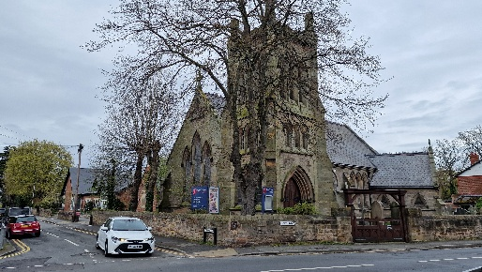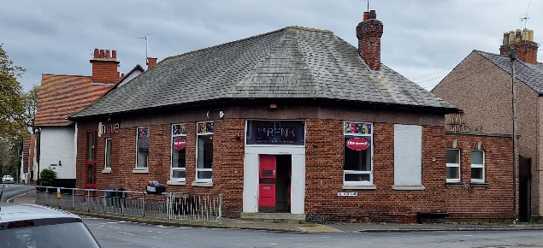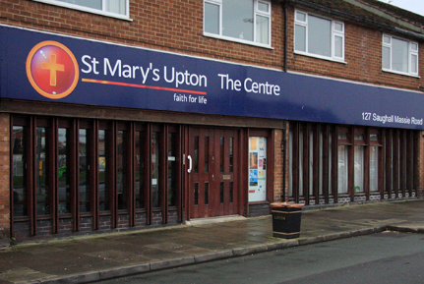

Who we are:

St Mary’s is a large evangelical Anglican church on the Wirral Peninsular, which has a long history of thriving work with children and young people. We are a friendly, welcoming, caring group of people from a wide range of age groups, backgrounds & Christian experience, all wanting to grow in knowing Jesus, and sharing his love.

We are a church community of about 400 people, meeting at St Mary’s (the main church building in the parish, with a large recent extension which serves the local community all through the week), The Centre (a church plant which meets in a couple of converted shop units at the other end of the parish), and The Bank (a former bank building which we own, and operate as a youth resource on the high street in Upton).

We also have an excellent and well-established relationship with Woodchurch Church of England High School (around 1400 pupils), where St Mary’s provides the school’s Chaplaincy Team (for 20 hours a week, funded by the school). This St Mary’s team (which will be led by the successful candidate) plays a significant role in shaping and maintaining the schools distinctively Christian ethos, its Collective Worship, and assisting with some pastoral support.

New strategy and vision:

Our 0-18’s team work with large numbers of children and young people every week, with around 70 pre-school children and their carers taking part in our mid-week activities; an after-school club for primary ages and active involvement in local primary schools; and over 50 secondary-aged young people taking part in a range of theatre, musical, leadership, bible study, residential and drop-in activities. You can find out more about our activities here: https://stm-upton.org.uk/children-and-youth/

Much of this work has grown out of the Village Youth Project, which was set up in the early 2000’s, offering a wide range of activities to young people from the community, designed to support and enable young people to achieve their emotional, social, moral and spiritual potential. The Project has, over many years, been very successful, and has run largely in parallel to the life of the wider church. Alongside the Village Youth Project, there has previously been a significant number of active church families with school aged children, with the vision being that young people would be naturally drawn into visible and active church and faith involvement.

This means that, in the past, 0-18’s work at St Mary’s has had three parallel streams to it:
- The Village Youth Project, offering community-facing activity-based groups, where faith in Jesus is modelled and can begin to be discovered
- ‘Church’ groups, where faith and discipleship can be explored more fully
- Chaplaincy at Woodchurch High School, offering opportunities for Jesus to be encountered within the Collective Worship and ethos of the school

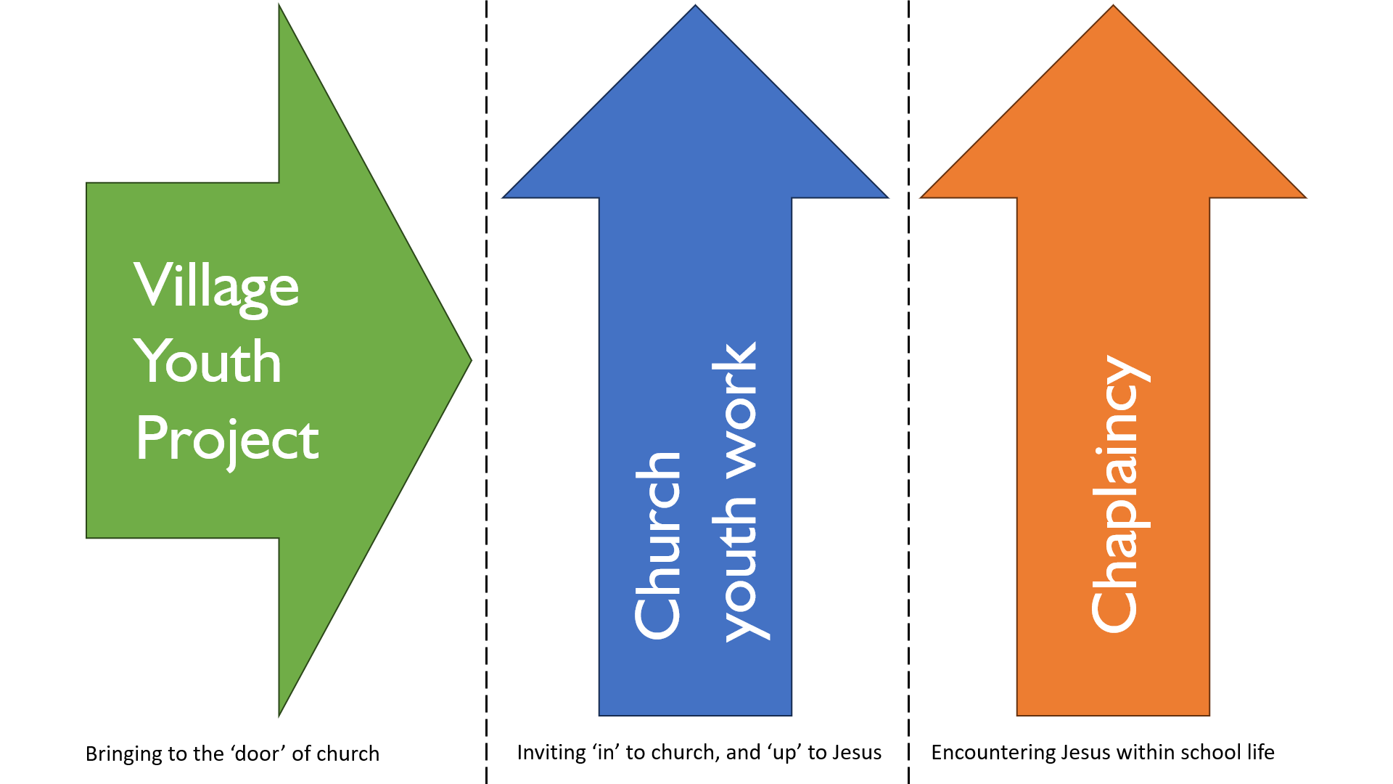

However, over recent years, as active church families and their children have grown up and ‘graduated’ from the youth and children’s work, they have not been replaced by as many younger families. This has led to a situation where the Village Youth Project and the Chaplaincy have continued to thrive, but the number of children and young people who are visibly and actively involved in the life of the wider church community has begun to reduce.

Recognising this, alongside preparations for the planned retirement of the current leader of the Village Youth Project, and the arrival of a new Vicar (whose appointment process highlighted the need to be developing our work with younger people), we have been forming a new vision and strategy for our work with children, young people and families.

Our new vision statement for this work is:

To make disciples of Jesus among children, young people and families.
Enabling everyone to find their active place in the life of the church, where they can discover their true identity in Christ, becoming the people Jesus is calling them to be.

The appointment of our new youth development & chaplaincy lead will be a key part of our new vision and strategy, which aims to build on the great links we already have with many children and young people. But instead of seeing our mid-week groups and activities as parallel to wider church life, we will be exploring ways for these activities to themselves become a visible and active part of the life of St Mary’s, with multiple ‘bridges’ and ‘stepping stones’ intentionally created to encourage young people and families to progress from ‘mid-week’ to ‘church engagement’. This will mean lots of creative thinking, a review of where current ‘mid-week’ activities fit into the new vision, and an enthusiasm from the wider church to welcome the active involvement of these varied groups in different aspects of our life.

By enabling this integration into church life, our prayer is that children and young people can grow a sense of belonging in the life of the wider church community, as we recognise that, for a majority, faith in Jesus grows out of the experience of being part of a Christian community.

Alongside these developments, both we and Woodchurch High School would like to continue our Chaplaincy partnership, because we recognise the value of excellent Collective Worship, Christian ethos and pastoral engagement within the life of the school. But we also recognise that it would be outside the scope of Chaplaincy to be specifically promoting St Mary’s church or St Mary’s activities within the school environment.

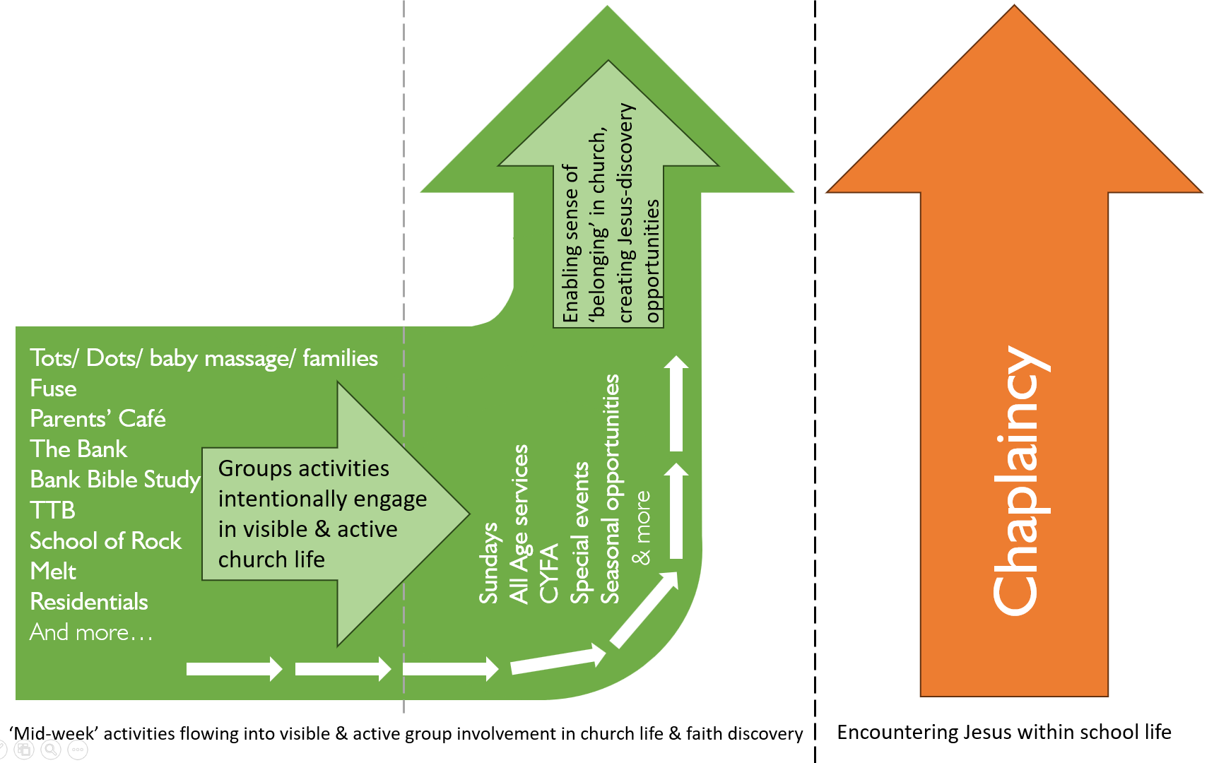

Exciting times:

We believe that this will be an exciting time to join the 0-18’s team at St Mary’s. And our children, young people and families are looking forward to welcoming the successful candidate too. Some of our young people have already started their wish list – they’re hoping for someone who is:

Role Description: St Mary’s Children and Young People’s Development Worker (secondary-age lead and Chaplaincy lead)

This is a full-time role (40 hours a week, inclusive of Sunday and weekend/evening involvement), with the post holder being responsible to the PCC, via the parish clergy. The salary is £27,976 per year.

Our vision and aims:

Or vision is:

To make disciples of Jesus among children, young people and families: Enabling everyone to find their active place in the life of the church, where they can discover their true identity in Christ, becoming the people Jesus is calling them to be.

We will seek to achieve this by:

- Creating welcoming and engaging environments where children, young people, and families feel safe, valued, and excited to explore faith.
- Building strong, supportive relationships and community, where people feel they belong and can grow together.
- Teaching and modelling the message of Jesus in relevant and compelling ways, helping each age group understand and apply it in their everyday lives.
- Helping children and young people discover their identity and value in Christ, and provide opportunities to develop their gifts, skills, and interests.
- Encouraging and supporting spiritual growth and discipleship, helping individuals to develop a personal relationship with Jesus.
- Encouraging active participation in church life, helping everyone discover their gifts and how they can serve.

Key Role and Responsibilities:

- To contribute to the design, and delivery of an effective integrated children and young people’s vision, strategy and plan, taking a lead on all elements of youth work associated with St Mary’s, and working other staff and volunteers to deliver this.
- Contribute to the planning and delivery of the work of the wider 0-18’s team.
- Provide leadership for volunteers within the work, by safely recruiting, encouraging, training, supporting and overseeing them to enable them to flourish in their volunteering roles.
- Lead the team’s delivery of Chaplaincy provision at Woodchurch Church of England High School (see below for more details). This currently accounts for 15 hours a week of the role, with the remaining 5 hours delivered by another member of the 0-18’s team.
- Lead in the planning and delivery of residentials for secondary ages.
- Work with the 0-18’s team, and the wider staff team and PCC, to grow and integrate work with families and young adults across the life of the church.
- To collaborate, alongside the rest of the 0-18’s staff, with the St Mary’s Treasurer team, to ensure the affordability and financial sustainability of our youthwork.
- To network with the Diocesan children’s and youth departments, and other local partners as opportunities arise.
- In partnership with the Parish Safeguarding Team, to actively promote, support and follow excellent Safeguarding practices, and to undertake Safeguarding training as required.

Flexibility, Team Working and using Individual Talents:

Because this role is part of a small 0-18’s team, individual lead and delivery responsibilities are identified according to the unique skills and circumstances of each staff member, and balanced between the team members and volunteers.

Chaplaincy at Woodchurch Church of England High School:

The Woodchurch Chaplaincy team is provided by St Mary’s under a Service Level Agreement (a total of 20 hours a week, funded by the school, with the hours shared within the St Mary’s 0-18’s team).

The Chaplaincy team are an integral part of the life and ethos of the school, with their contribution being highly valued by the Senior Leadership Team, staff and pupils. The Chaplaincy’s value to the life of the school has also been very positively commented on in recent OFSTED and SIAMS inspection reports.

The Chaplaincy Lead role, which takes place primarily during weekday mornings in term time, includes leading the Chaplaincy Team to:

- Create the Collective Worship plan for the year.
- Plan and create excellent Collective Worship materials for every form group in the school (uploading these resources to the School Drive for form tutors to access).
- Provide Collective Worship training to new form tutors when necessary.
- Deliver a ‘thought for the week’ every Monday morning in the 8.30am whole staff briefing, which links to the Collective Worship themes for the week.
- Support staff, pupils and families in difficult times.
- Attend and support the Archbishop Young Leaders awards activities.
- Visit staff in their subject area bases, offering a listening ear and supporting wellbeing.
- Promote prayer opportunities within the school community.
- Understand and enrich the distinctively Christian ethos of the school.

Person Specification:

 | Quality/ Skill/Aptitude | Essential/Desirable
1 | Mature Christian who will be actively committed to the life and evangelical values of St Mary’s Church: “Making a difference, wherever we are, as we share Faith For Life in Christ”. | Essential
2 | A passion to see children and young people follow Jesus | Essential
3 | Ability to build excellent, and appropriate relationships, with a wide range of people, including young people, adult volunteers, colleagues, school staff and the wider community. | Essential
3 | A servant heart. | Essential
4 | Experienced youth or children’s worker, able to relate well to all 0-18’s age groups. | Essential
5 | The ability to nurture and inspire young people in their discipleship, by example, and through the excellent and relevant communication of a biblically-based faith. | Essential
6 | The ability to approach different working environments appropriately and professionally. | Essential
7 | Excellent emotional intelligence, relational and listening skills, with an ability to build non-judgemental relationships inside and outside of church. | Essential
8 | A proactive self-starter who takes initiative. | Essential
9 | A willingness to do what is needed to get the job done, with energy and resilience. | Essential
10 | Able to work independently and as a team member. | Essential
11 | A thorough understanding of safeguarding, and commitment to its ongoing application. | Essential
12 | The ability to manage their own time – prioritising and delegating. | Essential
13 | The ability to work at all times within the Values of the Children and Young People’s dept. | Essential
14 | Good IT skills. | Desirable
15 | Possession of a full UK driving license, and ability or willingness to learn to drive a minibus. | Desirable

There is a Genuine Occupational Requirement for the postholder to be a committed Christian.

At St Mary’s we take our Safeguarding responsibilities seriously, and this appointment process will follow the Church of England’s Safer Recruitment procedures. The role is conditional upon the holder having an enhanced DBS check (with barred list) and being entitled to work in the UK.

To apply:

Please send your completed application form to office@stm-upton.org.uk, 0151 677 1186
Application deadline, 5pm Wednesday 20st May 2026.
Interviews for shortlisted candidates, Wednesday 17th June 2026.

