
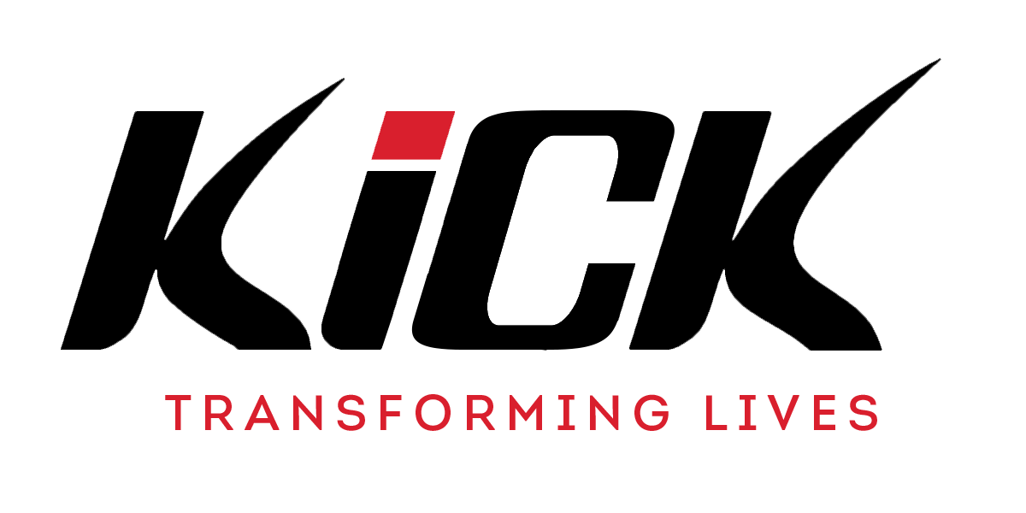
Job Application Pack

KICK’S MISSION
At KICK, we are motivated to respond to a sense of hopelessness in many young people today as 1/3 of young people aged 15 identify with a mental health condition, 2million grow up without a father at home, many are disconnected from local communities with 95% now not attending church. We aspire to see a generation of young people who will reach their God given potential; where communities have been socially impacted; and where spiritual change has transformed a nation. Our mission is to transform young people’s lives, with God's love, through sport and support. We do this through values-driven physical education, street dance, mentoring, chaplaincy in schools and community KICK Academies to impact a sense of hopelessness and give them a hope for the future and a joy in the present.

KICK work in Infant, Primary, Secondary, Pupil Referral Units, Private and Special Schools to deliver the following services with Christian values embedded throughout every session:
- PE National Curriculum - Transformational Street Dance
- Solutions Focused Mentoring - Schools based Chaplaincy

In all that we do we seek to live out our values to encourage young people to be aspirational, to be compassionate in all circumstances, to deliver excellent quality sessions, and to be intentional in building relationships and sharing the gospel with young people every day and to show integrity in our decision making at all times. KICK are currently working with over 100 schools and have established 30 KICK Academies. Our staff team has more than doubled over the last 2 years with KICK now employing over 90 staff. As an organisation we are engaging with over 28,000 young people every week and come closer to achieving our mission as we reach more and more young people.

KICK APPLICATION PROCESS
Please send the completed KICK application form and covering letter to our HR Manager – beccilee@kick.org.uk
Your covering letter should include the following areas and should clearly show how your skills and experience meet the requirements for this post.

Aspirational - We believe in being aspirational towards our young people and in all that we do.
How are your skills and experience relevant to this post?

Compassionate – We believe in showing compassion to every young person we engage with.
Please tell us about your experiences as a Christian and how you have showed compassion within interactions with children, colleagues and key partners.

Excellence – We believe in thriving for excellence in every area of our work and learning. Please tell us about your previous experience where you have shown excellence in your approach and execution of projects or sessions.
Intentional Relationships – We believe in taking opportunities and making intentional relationships with both young people and partners of Kick. How are you suited to serving and developing the work of KICK?
Integrity – We strive to be a people of integrity in our actions and all our decision making. What makes you stand out from others to make us bring you in for interview?
If you do have any questions, please connect beccilee@kick.org.uk

KICK JOB DESCRIPTION

Title: KICK Behaviour Support
Based in: Stoke
Hours of work: Full Time

Role purpose
To deliver KICK Behaviour Support in, but not limited to, schools and community projects. Coaches will be able to:

- Supporting students through the building of positive relationships
- Classroom support, collaboration with class teachers, provide behaviour interventions
- To help manage behviour using de-escalation techniques and strategies, delivering restorative justice approaches to help build positive relationships between pupils
- To communicate with parents regarding strategies and progress
- To maintain accurate records, report on progress and assisting in the writing of plans and policies
- Serve as a role model by reflecting KICKs ACE11 values
- Deliver simple mentoring and/or sport sessions when needed.
- Achieve the vision of “Transforming young people’s lives by God’s love through Sport and Support”.

Key Responsibilities and Accountabilities:

- To support the wider Behaviour and Pastoral team with the school
- To take on assigned Behaviour tasks as directed by school as part of the Behaviour Team
- Report weekly to the school around pupils needs, progress and goals using key reporting paperwork.
- To be a role model to young people in terms of Sports skills, fitness, spiritual leadership and pastoral care.
- Every member of the KICK staff team has a responsibility and role to play in protecting children from harm within their working environment. This involves adhering to policy and legislation, understanding of reporting channels and high standards of professionalism.

Person specification
General Characteristics
- A committed Christian, in line with KICK’s Christian ethos.
- A satisfactory enhanced DBS Disclosure.
- Awareness of personal capability and effectiveness and the need for self-improvement.
- A willingness to travel to different locations when required.
- Punctuality and reliability.

Abilities

- To have good interpersonal skills; relates well to people within Kick London, education, Churches and other organisations.
- To be team oriented; co-operates in and is committed to team activities and decisions, working effectively in partnership with others.
- To be able to understand and appreciate the values, concerns or feelings of others.
- To have good communication skills; to communicate effectively with a wide range of people, both written and verbally (on one-to-one and one-to-many basis).
- To identify and provide opportunities to enable other people to reach their full potential.
- To be flexible and open minded in order to respond to changing needs or circumstances.
- To be able to deliver quality results and outcomes in a professional manner.

 | Essential | Desirable
Knowledge and  Qualifications | - Knowledge of Safeguarding and keeping children from harm.  - Knowledge of contributing factors to young peoples behaviours within school.  - Awareness of Health and Safety issues.  - Knowledge of behaviour management strategies. | - National Governing Body Level 1 award (or higher) in at least one Sport.  - Health and safety training.  - First Aid training.  - Knowledge of different SEND needs of young people.
Experience | - Experience of working with young people aged between 5 and 11 or 11-16.  - Experience of implementing effective behaviour management and addressing behaviours.  - A healthy and active lifestyle. | - Experience of working within a school setting  - Experience of delivering mentoring.  - Experience of pastoral care.  - Experience of conducting outreach duties  - Experience of Recording data for Daily, Weekly, Monthly and Quarterly Behavioural Logs.

Next Steps
1. Please complete the KICK application form and cover letter and send this to beccilee@kick.org.uk
2. All applicants will undergo an identity check and DBS check as well as being required to provide 2 references.
If you do have any questions regarding your chosen vacancy, please connect beccilee@kick.org.uk

